Dr. Timothy Maciag
ENSE 281: Software Systems Design
Final Project Report Out
Glen Issac (200499313), Gabriel Sampaga (200426525), Amr Azouz (200506317),
Cobie Caburao (200436566)
Table of Contents
- Requirements
  - Function Requirements
    - Submit items and reports separately to database and custom “Other” tags for Location and Category
    - Custom “Other” tags for Location and Category
  - Technical Requirements
    - Web-based Application
    - Mobile compatibility
- Were goals achieved?
- What feedback did you receive throughout?
- How did feedback impact/change project decisions (if at all)?
- Prototypes
  - Low-fidelity prototype
  - High-fidelity prototype
- Scrum/Sprint Meetings
- Acceptance Test-Driven Development (ATDD)
- Refactoring
- Reflection
  - Lessons learned
  - Overcoming obstacles
  - Thoughts on the project
  - Personal accomplishments
  - What we learned about ourselves through collaboration on the activity
Requirements

Function Requirements
Submit items and reports separately to database and custom “Other” tags
for Location and Category allows users to add a specific location not listed.
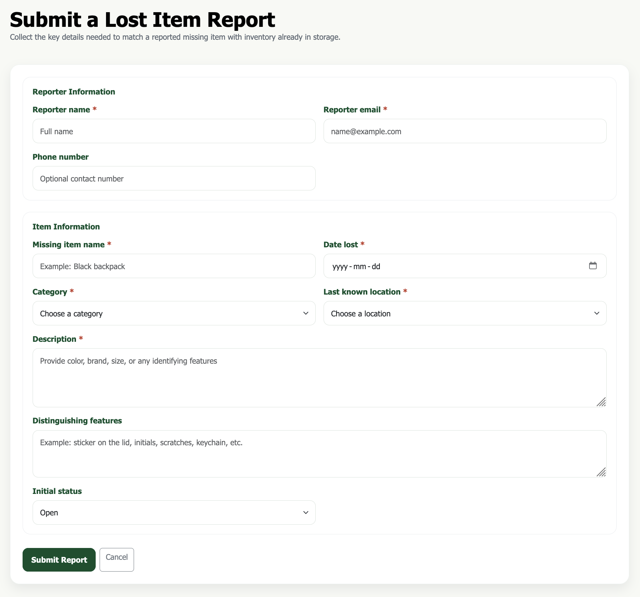
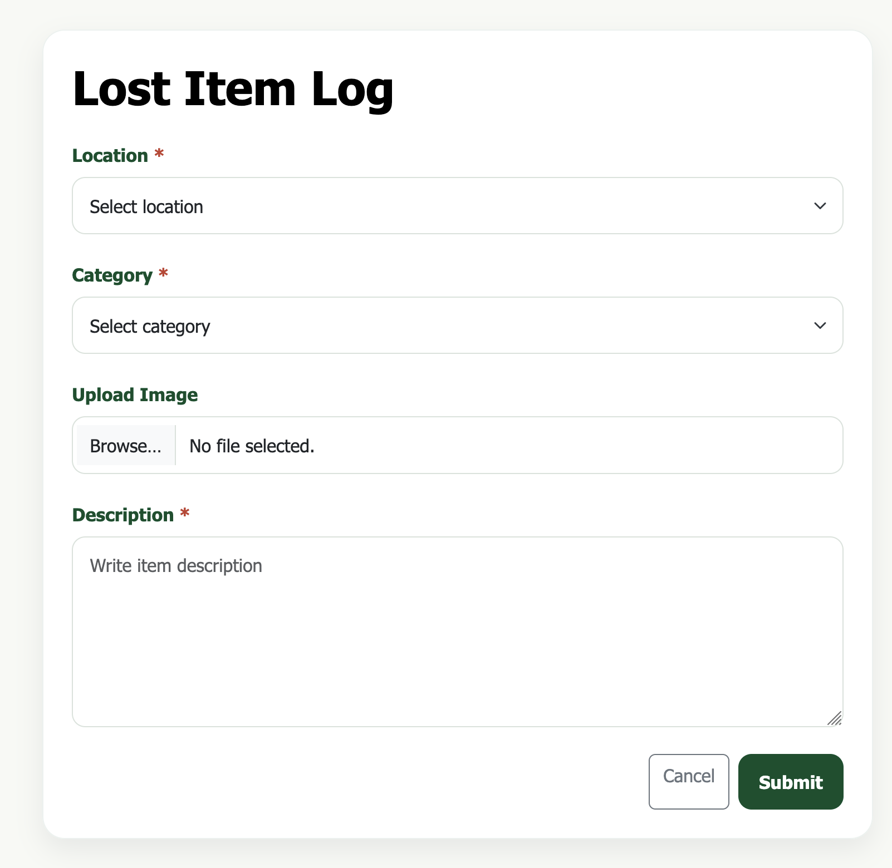

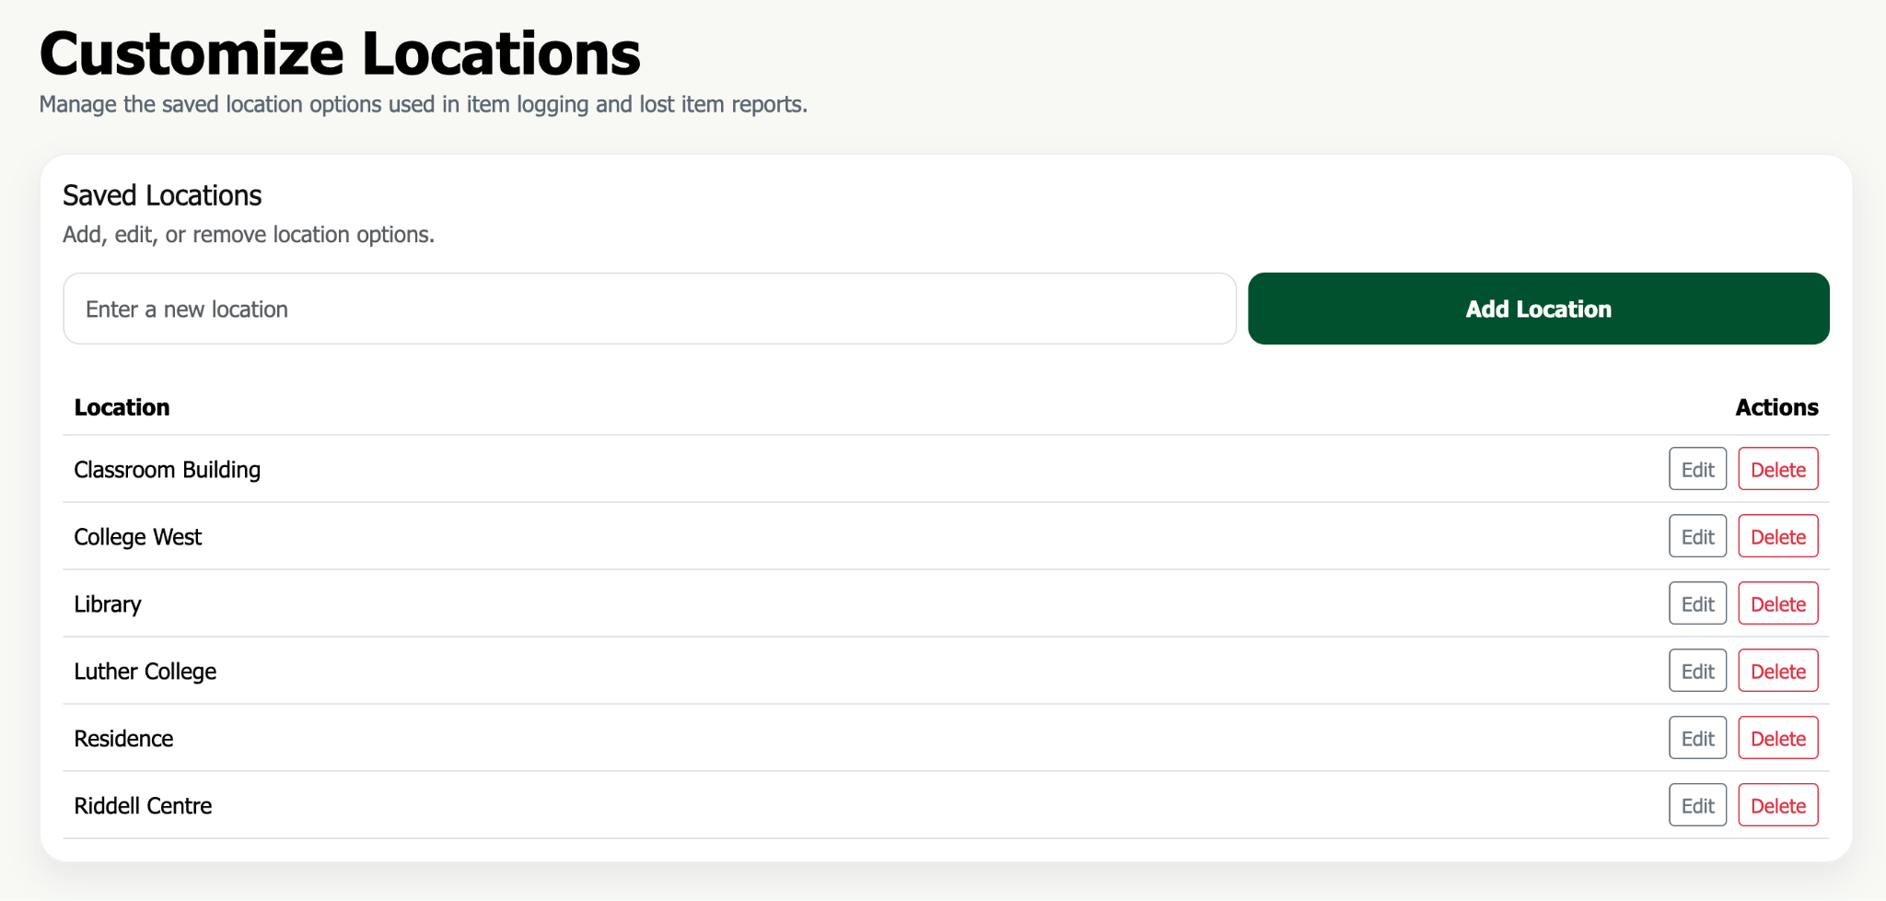
Custom “Other” tags for Location and Category allows users to add a specific location not listed.
- Administrators are able to modify tag options through the application.
- Encrypted passwords
- View list of items in the database
- View list of reports in the database
- Edit status and other item information
- Edit status and other report information
- Create processing instructions for items
- Resolved items and reports are moved to an archive bin separate from the open lists
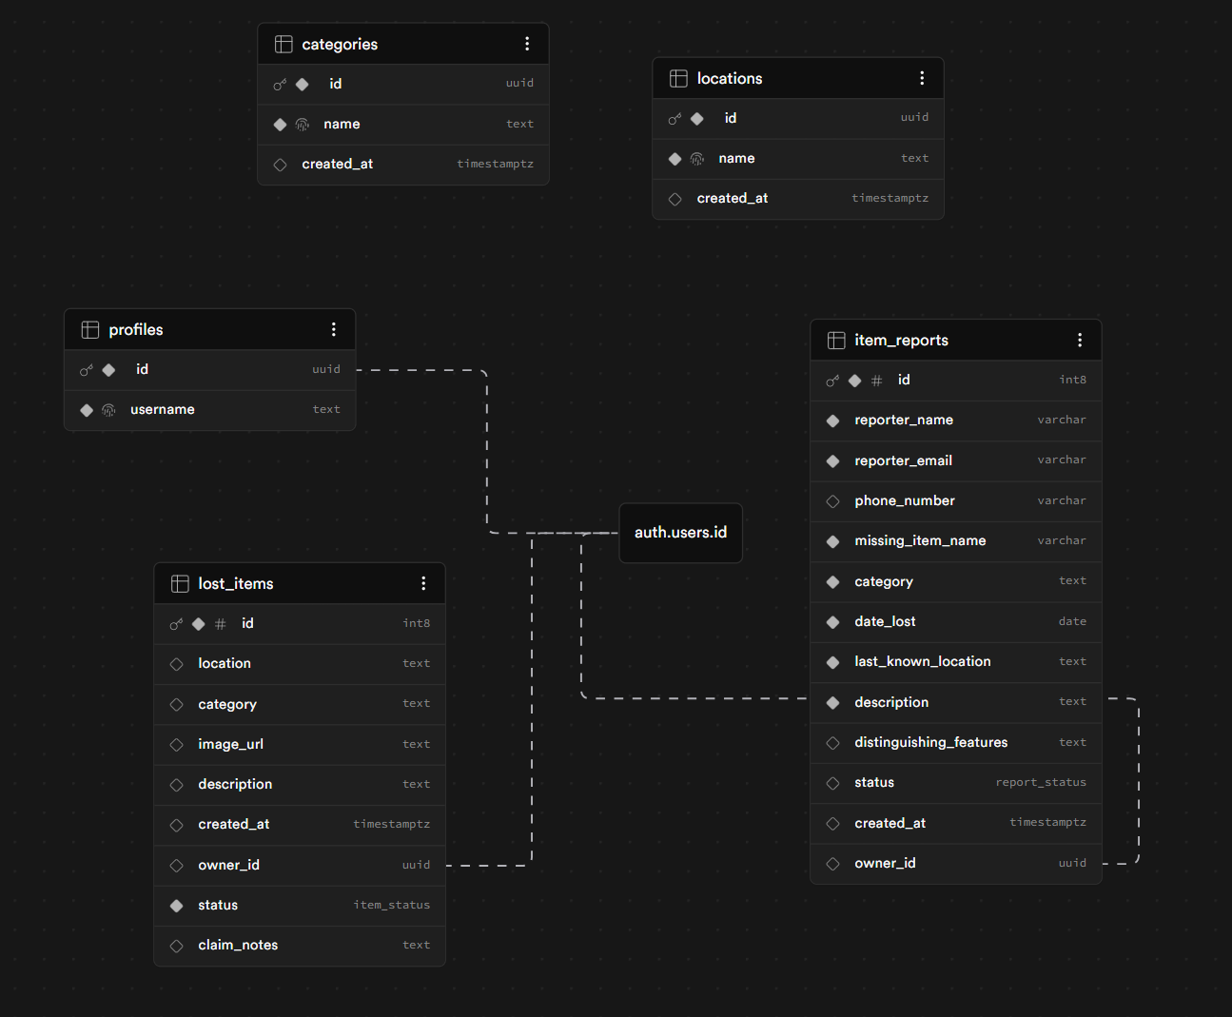
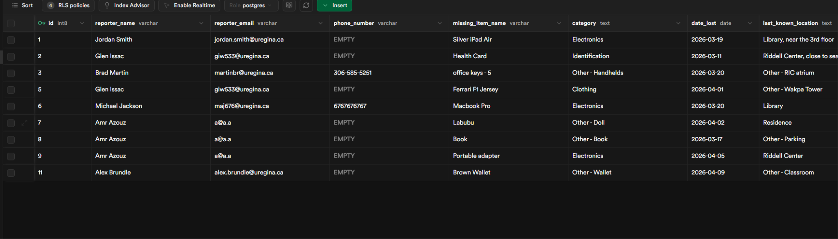
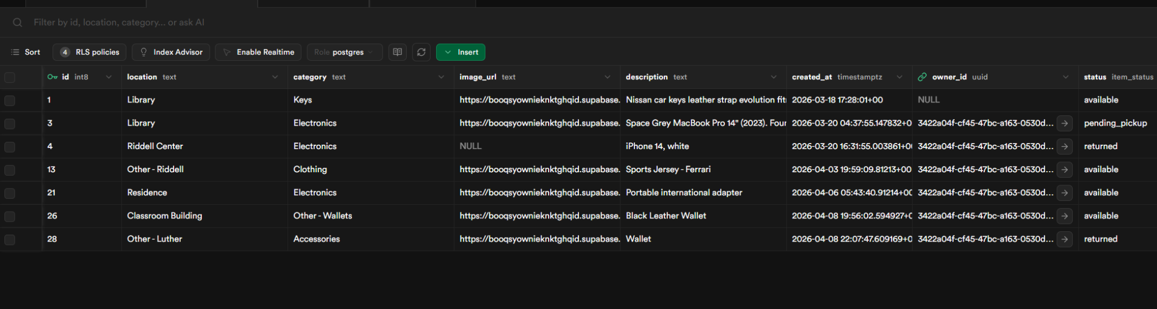

Technical Requirements

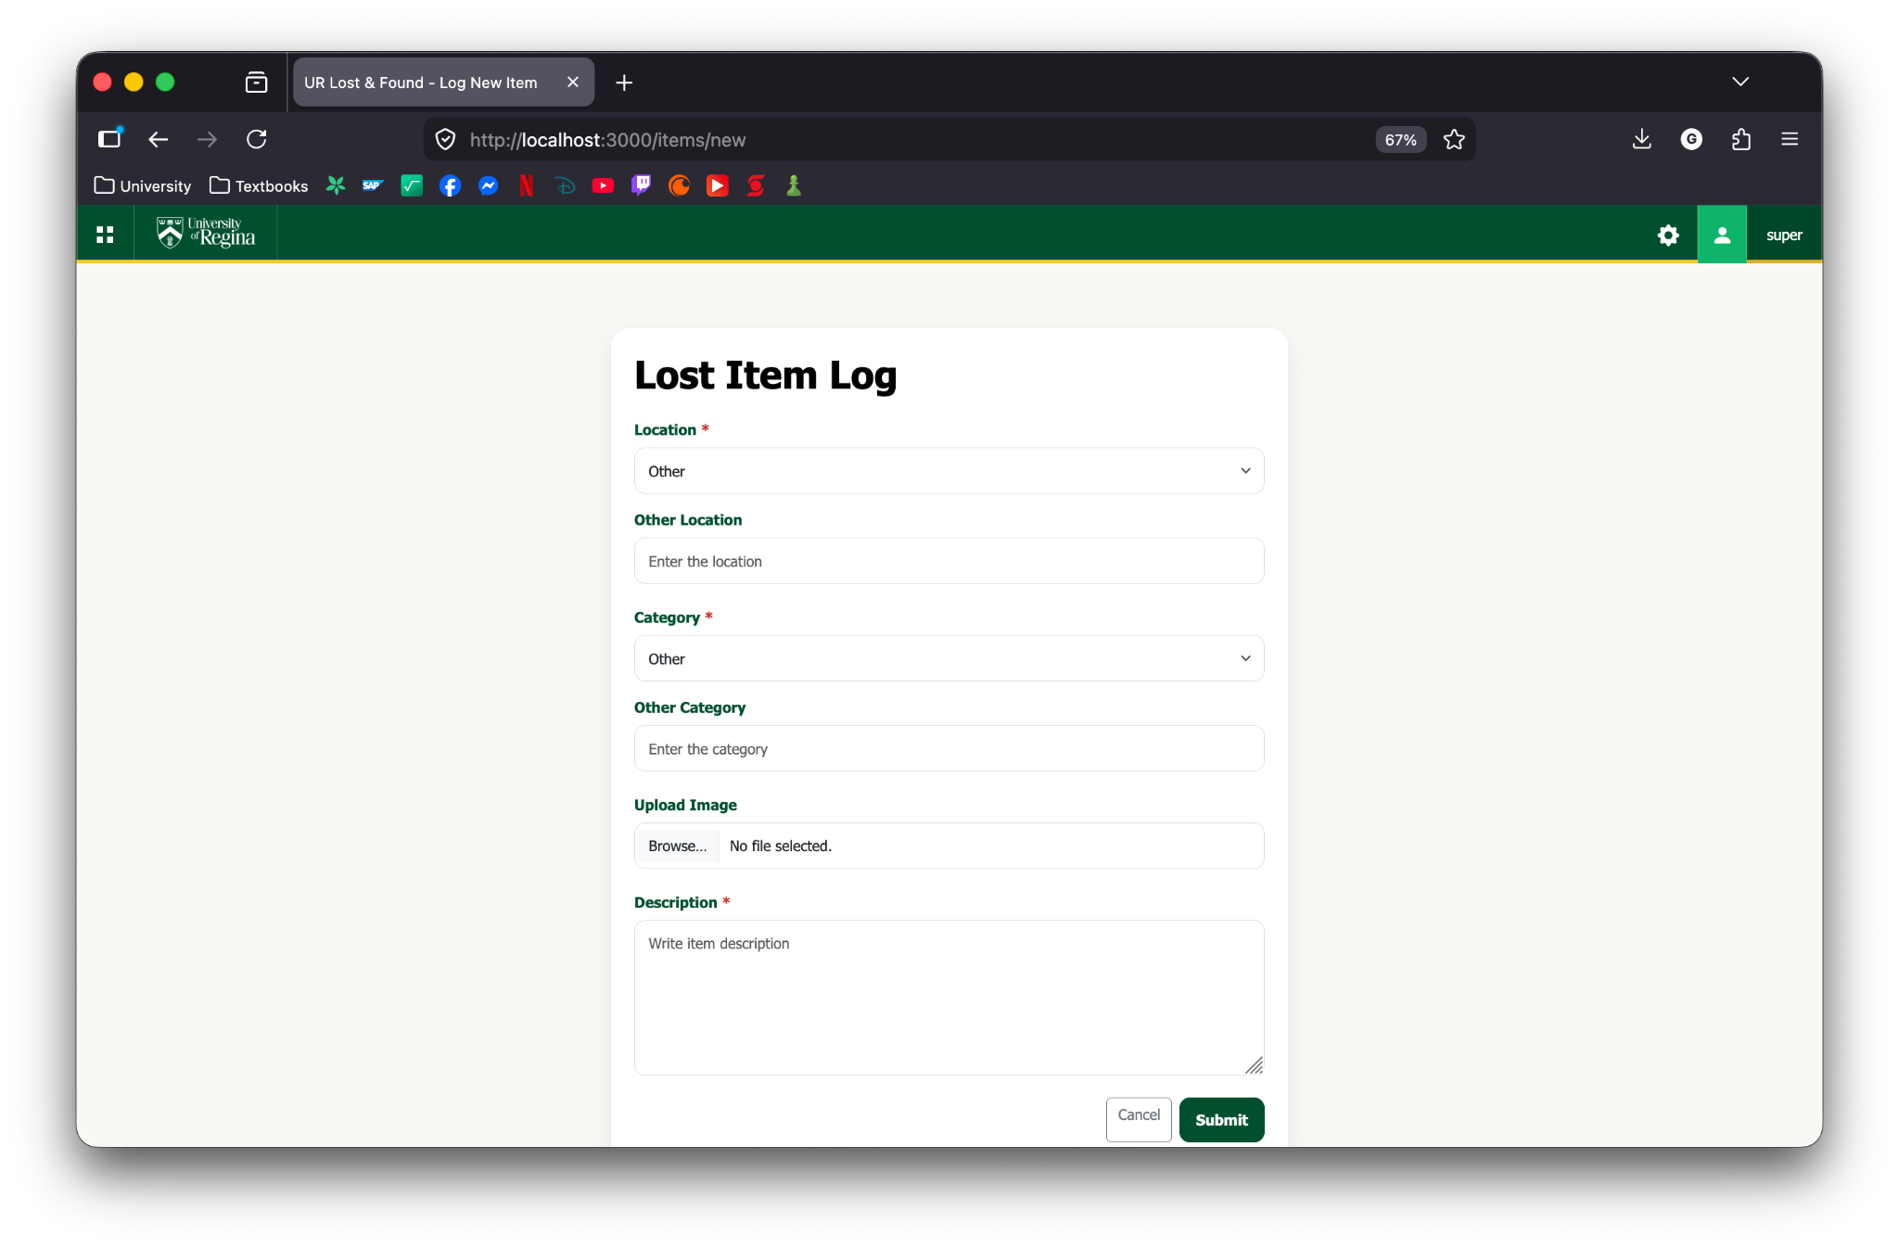
Create a web-based application

Mobile compatibility
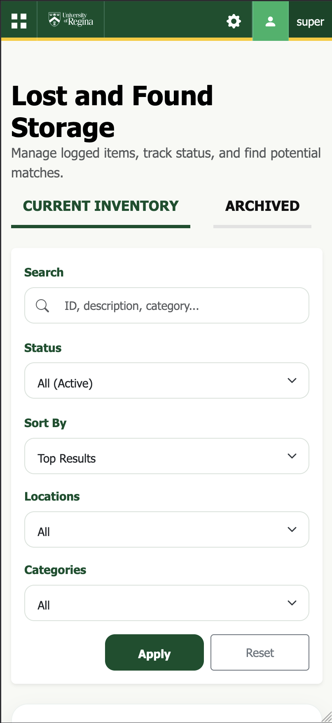

Were goals achieved?
Yes, the primary goals of the project were achieved. We successfully completed and delivered MVP 1 through MVP 3 by the final project deadline and handed them over to Brad Martin. The main remaining step is deployment, which is still being discussed with University of Regina Information Services. We have also explored alternative deployment options, including VPS services such as AWS Lightsail and Railway, as well as domain name costs with Brad Martin. Overall, the project goals were met, and we will continue working with Brad Martin on deployment.

What feedback did you receive throughout?
During the project initialization phase when presenting the project proposal to Brad Martin, the Associate Director Campus Safety, Parking & Transportation, he emphasized maintaining consistent visual identity with the University of Regina as well as the necessity of a Role-based Access Control Model restricting the access of allowable actions of the Lost and Found application solely to Protective Services. Brad Martin provided suggestions regarding the item and report forms, such as adding options for all the buildings on campus as well as an option to customize the option for “Other” to allow more flexibility for tagging items. An option to leave notes or instructions attached to items in the database to aid in the transparency of processing pick-ups amongst all staff members and the person requesting the pick-up was suggested by Brad Martin. Feedback during the initial prototype demos with Dr. Maciag and our peers mainly focused on the lack of distinction between the item management buckets and report management buckets as well as the grouping of the buckets which were originally based on the functionality (the buckets for submitting items and reports were grouped together, and the bucket to view the list of items in the database and view the list of reports in the database were grouped together).

How did feedback impact/change project decisions (if at all)?
The original scope and direction of our project was to allow different building locations that hold their own lost and found box to use the application. This would make the responsibility of the lost and found to be divided amongst campus staff, consequently leading to more immediate and frequent updates to the database of lost items. The requirements posed by Brad Martin, the Associate Director Campus Safety, Parking & Transportation, forced us to change our scope and direction for strictly Protective Services use. The other suggestions from Brad Martin, the Associate Director Campus Safety, Parking & Transportation, were included as functional requirements for our minimum viable product (MVP). Feedback on our prototypes were implemented to improve user experience for the main menu page.

Prototypes

Low-Fidelity Paper Prototype
Our paper prototypes helped pave the way for our final outcome by allowing our team to produce many different ideas in quick succession to discuss with our client Brad Martin. We were able to experiment with different user interface (UI) layouts and brainstorming signifiers such as icons.

High-Fidelity Figma Prototype
The figma prototype gave the client a more concrete vision of what the final outcome would look like and let them fine tune small UI decisions like color scheme, font choices, and other features that are non-functional in figma that they would like as functional requirements.

Scrum/Sprint Meetings
Meetings held with the class, Dr. Maciag, and especially Brad Martin influenced the choices for key interactions of our MVP with an abundance of feedback regarding suggestions and weaknesses or holes each iteration of our project had.

ATDD
Given a member of protective service staff is logged in, when completing the process of filling out and submitting a form for items or reports, then the item or report is immediately available to view and edit.

Given a guest comes to protective services, when looking for an item they lost, then protective services staff can quickly and efficiently check through all the lost items in their possession to process the guests report.

Given a lost item matching the description of a previously recorded and unresolved report, when logging items handed into protective services, then staff can contact the reportee and leave instructions for pick-up linked directly to the item for the next staff to view and follow for faster return process.

Refactoring
During the development of our back-end files, specifically the Node.js file, a very clear code smell being a God class/function was forming with app.js exceeding 1000 lines of code. We were able to refactor and divide app.js to make readability, understandability, and future changes much easier.

Reflection

Lessons Learned
The main lesson learned is the importance of the golden circle (Why? How? What? Who?) and project management documentation especially for project initialization, requirements and responsibilities.

Overcoming Obstacles
The main obstacles our group ran into were related to scheduling and the lack of experience in web development. Our group was able to make progress in occasional large bursts when our schedules allowed it and we overcame our lack of experience through external materials such as youtube videos.

Thoughts on the Project
This project was very gratifying to work on because we gained experience and further knowledge on how to work with other individuals as a group. We liked the fact that we slowly but surely found our role in the team, to which we designated ourselves based on our strengths and our weaknesses. We disliked the limited timeframe we were allowed to work with, however we would love to expand and work with the customer over our own time.

Personal Accomplishments
We have a lot to be proud about, and one was being able to work closely with the Associate Head of Security, Bradley Martin, to get a better insight on how the UR Lost & Found web application can be more efficiently used by Security Personnel. However, our team is most proud of being able to implement the technical needs that Bradley suggested, such as the text-editable locations and categories, as well as mobile-compatibility. Being able to complete the tasks Brad set out for us to do was gratifying, especially as a Software Engineering student. We, as a team, were able to gain some experience on client-customer relations through these activities.

What did you learn about yourself as you collaborated and worked on this activity (individually and as a team)
Gabriel: Through this project, I found that I wanted to work on leaving an impact through presentations and thorough documentations of our products and progress to our clients, but I still have a long way to go in my coding journey. I was not able to help as much as I thought I would in developing the backend, but my lack of work put into the code can be attributed to my team’s ability to complete the MVPs without my input. I am thankful for the team’s hard work and their trust in me to direct the presentations and documentations.

Cobie: Through this project, I learned how much easier it is to have proper plans laid out through the Project Initialization and Project Requirements phase. I learned that having clear objectives and responsibilities makes my job and everyone else’s job easier to do. When working on a team it is important to be constantly communicating responsibilities and expectations of yourself and the rest of the team to keep everyone accountable.

Amr: Through this project, I learned a lot about leading a team and taking responsibility for the front-end development of our product. As the Front-end Lead and Team Lead, I worked on guiding the team’s direction, helping organize tasks, and making sure our progress stayed aligned with our goals and client expectations. I also gained valuable experience in designing and improving the user-facing side of the system, while balancing leadership responsibilities throughout the project. Overall, this project helped me grow not only technically, but also as a leader and collaborator.

Glen: Throughout the course of this project, I have learned to compose myself better and learned to be much more receptive to different outlooks on how a problem can be tackled. I believe this project has helped me develop programming as well as people skills and this will percolate into working in industry in the future. I appreciate collaboration much more and like being a team player.

Team: The entire project had many obstacles the team had to overcome, but we found ourselves being able to tackle each problem as a group. In those moments of turbulence, each person in their respective roles did spectacular work in mitigating the problems that arose. Not one singular person in the team needed to be babied the entire project.

How will you use (or not use) what you have learned/experienced in this activity going forward?
Gabriel: Going forward, I will extend my ability to code to help my team in developing the product to completion. I regret not being as useful as I wanted to be in developing the backend, but this project made me realize that I have a lot to improve on myself. Moreover, I found myself to be useful in directing the presentations, and “selling” the flow of the presentation to the team is just as important, in order to successfully execute our collective vision for how the presentation would go.

Cobie: I really appreciated the information regarding project documentation that was required for this project. I also found the experience of working closely with a client, even more so than ENSE 271, very encouraging and something that I would like to try more of. For future projects I will definitely be using my experience in documentation to organize and identify key information. I enjoyed and felt I excelled in the Question and Answer portions of our presentations compared to just presenting off slides. I would like to experience more personal and interactive meetings where I can both ask questions and answer questions when working on future projects.

Glen: This project helped me learn more about full stack development and how both client satisfaction as well as clean and efficient code matter when dealing with real world scenarios. It gave me a great amount of exposure with the Scrum and Agile framework, working and dealing with differing opinions on a team, compromising where possible. We also presented both to our customer and the class (carryover stakeholders) which made this problem feel all the more realistic. I hope to work on more such projects and be able to contribute to solutions that make lives easier.

Amr: Going forward, I will use what I learned from this project to grow both as a front-end developer and as a team lead. Working on the front end helped me better understand how important usability, presentation, and user experience are in creating a product that people can actually benefit from. At the same time, serving as team lead taught me the value of communication, coordination, and making sure the team stayed aligned with our goals and deadlines. This experience showed me that strong leadership is not only about directing the team, but also about supporting others, keeping progress organized, and helping turn ideas into a finished product. In future projects, I want to continue improving my technical skills while also building on the leadership, planning, and collaboration skills that I developed through this activity.

